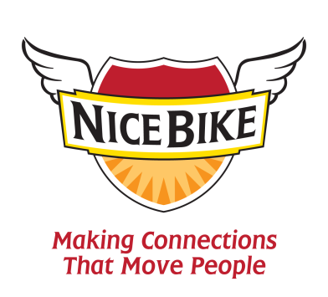

In 1984, I invited my dad to take a trip with me to Washington, D.C. I was giving a big speech. In fact, I was sharing a stage with First Lady Nancy Reagan. Well, she spoke the day before me, but it was the same stage! I begged my mother, “Please, Mom, make the trip with us.” But she couldn’t be persuaded. “No, Mark, I just don’t want to go. Take your father, and do me a favor.”
It was a great trip. My dad enjoyed my presentation, and we toured the city together. The last monument we planned to visit was the Lincoln Memorial. We ended up there late in the evening. Other than Abraham Lincoln, it was just my father and myself standing there that night. It was a very powerful moment when we sensed the greatness that this country was built on.
We left the Lincoln Memorial around 11:00 p.m. and took a left along the Mall. In just a short time, we came upon the Vietnam Memorial. It had only been there for a few years at that time. The first thing that came to my mind was the number 256.
That was my lottery draft number from the Vietnam War. A lot of men volunteered to serve, and a lot of men were drafted to serve. 58,178 names are engraved in polished black granite on the Vietnam Memorial. The first American soldier killed in the Vietnam War was Air Force T-Sgt. Richard B. Fitzgibbon Jr., and the last was Kelton Rena Turner, an eighteen-year- old Marine. He was killed in action on May 15, 1975, two weeks after the evacuation of Saigon. With the exception of the return of our prisoners of war, those who came home from their service in Vietnam weren’t welcomed home with parades. Unlike the WWII returning soldiers, there were no cheering crowds of people or banners hung throughout their towns. When I ask Vietnam veterans to tell me about the toughest part of the war, many of them say, “coming home.”
As my dad and I were walking along the memorial, we noticed two Vietnam vets standing close to the wall. They were wearing their Army jackets and silently staring at the engravings of the names of their fellow soldiers. My dad slowly walked over to the two men and said, “Excuse me. Were you fellows over there . . . Vietnam?”
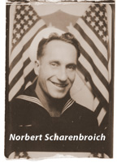
“Yeah. Yeah, we were,” said one of the men. After a long pause, my dad said, “Thank you, fellows. Welcome home.”
“Sir, you are the very first person who has ever said thank you to me for serving my country. That means a lot, man.” At that point, the Vietnam vet moved closer to my dad and gave him a big bear hug. Then, the other Vietnam vet did the same. My dad was not known as a hugger, but he gave a big hug back to each man. I noticed tears in the eyes of the Vietnam veterans and in the eyes of the WWII veteran — my father. That was the first and last time I ever saw tears in my father’s eyes.

Dad acknowledged the Vietnam vets, honored their service, and connected with them on a very personal level. It’s a moment I will always cherish. I didn’t know it at the time, but it was the ultimate Nice Bike.
Acknowledge, honor, connect, and you will change the world, one person at a time.
NICE BIKE, Dad.
[Excerpt from the book Nice Bike, by Mark Scharenbroich. ©2010, Echo Bay Publishing. Reprinted with permission.]
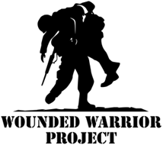
A portion of the proceeds from the sale of the Nice Bike Book will go to veteran’s organizations. Please feel free to make a direct contribution to some worthy and tireless Veterans' groups through the links below. And thank you.

Veterans of Foreign Wars Disabled American Veterans Wounded Warrior Project

