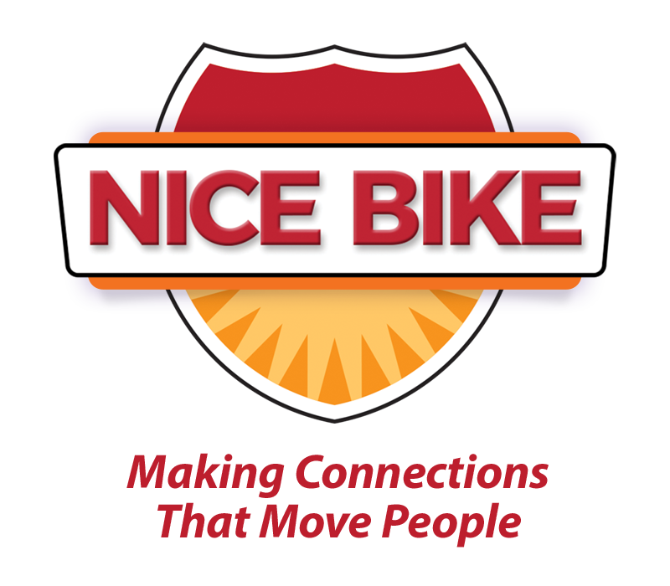
Introduction for Mark Scharenbroich
(Last name is pronounced “Sharon-brock”)

One of the many lessons we have learned from the pandemic is how vital human connection is to all of us. Although we are surrounded by technology and screens, Wi-Fi alone isn’t enough to fulfill our social needs.

Face to face interactions matter. Human connection is the exchange of positive energy between two people. A research study by Harvard, conducted over a period of 80 years, proves that human connections and healthy relationships are the number one and two drivers of longevity.

Human connection is also the heartbeat of the business world. High-quality human connection motivates, builds trust and inspires change. In a culture where team members feel connected and valued, retention improves, sales increase, customer loyalty soars and our business grows.

Today, you will be hearing messages that are designed to fuel our passion to both connect and serve others.

Keynote speaker, Mark Sharon-brock wrote an award-winning book on human connection, entitled: Nice Bike – Making Meaningful Connections on the Road of Life.

Mark has spent his career working in both education and business discovering how some of the best organizations and industry leaders build a culture that encourages personal and professional growth.

Mark is a native of Minnesota, is an Emmy award-winner, Hall of Fame speaker and cited as one of the top 30 motivational speakers by Global Gurus. He is a Scorpio, enjoys long walks on the beach and bacon.

Please welcome Mark Sharon-brock.

