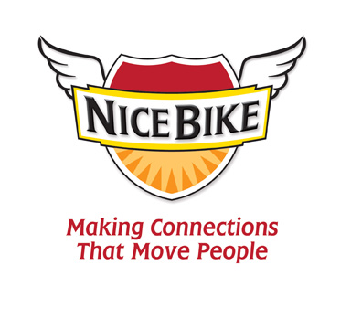
Biography/Introduction for Mark Scharenbroich
(Last name is pronounced “Sharon-brock”)

Today’s speaker, Mark Sharon-brock, is a native Minnesotan who has spoken to more than 3,500 audiences, earned an Emmy award, and been inducted into the National Speakers Association’s prestigious Hall of Fame.

Mark has spent his career working in both education and
business, discovering how some of the best organizations and industry leaders build a culture that encourages personal and professional growth.

You’ll be hearing messages that are designed to improve
everyone’s engagement at work, enhance team collaboration and fuel our passion to serve others.

Mark is the author of the award-winning book entitled, Nice Bike – Making Meaningful Connections on the Road of Life.

His method is unconventional and fun.

Please welcome Mark Sharon-brock.

