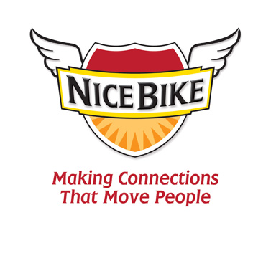
Introduction for Mark Scharenbroich
(Last name is pronounced “Sharon-brock”)

Connections – when a school community is truly connected, a good school transforms into a school of excellence.

Today, you will be hearing messages that are designed to support educators in their efforts to work collaboratively in reaching and teaching every child.

Our speaker, Mark Sharon-brock has spoken in more than 3,500 school districts. His message is about making connections that move people. He will remind us of the significant correlation between a student’s success in the classroom and the quality of the personal connections in the schoolhouse.

Mark is the author of the award-winning book entitled, Nice Bike – Making Meaningful Connections on the Road of Life.

Mark is a native of Minnesota, is an Emmy award-winner, Hall of Fame speaker and award winning filmmaker. He is a Scorpio, enjoys longs walks on the beach, bacon and beekeeping.

Please welcome Mark Sharon-brock.

