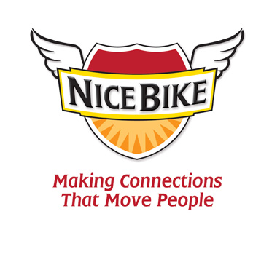
Introduction for Mark Scharenbroich
(Last name is pronounced “Sharon-brock”)

Today’s speaker, Mark Sharon-brock is a native Minnesotan who has spoken to more than 3,500 audiences, earned an Emmy award, and been inducted into the National Speakers Association’s prestigious Hall of Fame.

You’ll be hearing messages that are designed to support
educators in their efforts to work collaboratively in reaching and teaching every child.

Mark’s message is about making connections that move
people. He will remind us of the significant correlation between a student’s success in the classroom and the quality of the personal connections in the schoolhouse.

Mark is the author of the award-winning book entitled, Nice Bike – Making Meaningful Connections on the Road of Life.

His method is unconventional, unforgettable, and fun.

Please welcome Mark Sharon-brock.

