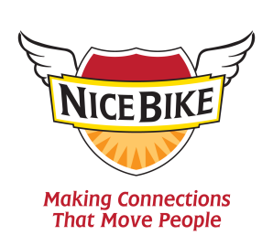

Title: “Nice Bike” – Making Meaningful Connections.

Mark Scharenbroich shares core messages on how to build strong connections in the workplace that result in improved performance across the board.

Mark has spent his career working in both industry and education discovering how some of the best organizations and team leaders build a climate that encourages people to perform at a higher level through greater engagement.

The message is all about making meaningful connections, creating better relationships resulting in growth for the organization. Mark’s Nice Bike principle serves as a metaphor supported by the actions of acknowledging, honoring and connecting.

Do you enjoy laughing? The guy is really funny.

Credentials: Award Winning Author, Emmy Award® winner for an ABC TV special, National Speakers Association Hall of Fame Inductee, Golden Apple and Silver Screen Film award for his movie, The Greatest Days of Your Life…(so far), International film festival award winner. www.NiceBike.com Twitter: NiceBikeMark

