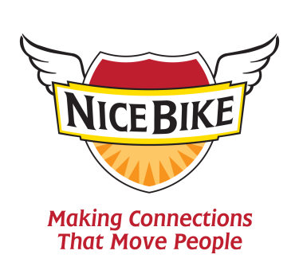

The Foreword to Nice Bike, by Mark Sanborn
One of the highest compliments we can give another person is that we really connected with them. That’s because we long for meaningful connections with others. I believe we are designed to be relational, and the quality of our connections largely defines the quality of our lives.
Think about it: How well do you connect with your spouse? Your kids? Your friends? Your colleagues? Your customers? Have you been able to create the kind of relationships that you desire? That they desire to have with you?
If there is room for a little (or even a lot) of improvement, don’t be discouraged. In this age of perpetual distraction connecting is difficult. So many things prevent us from truly connecting in our personal and professional lives.
Some people give up trying to connect and live in a self-imposed form of isolation.
Others attempt to connect and are frustrated by their lack of results.
A few seem to understand how to consistently and genuinely connect with others, and we admire them for their ability.
My friend Mark Scharenbroich not only understands the importance and power of connections, but he has written this simple and profound book that shows you how to do it.
Before I tell you about the book, let me tell you a little bit about Mark that won’t be on the dust jacket. He is a genuinely nice human being — the kind of person you’d enjoy fishing with or having a beer with, or both.
He is a clear communicator who doesn’t try to impress you with how clever he is, yet he does impress you with the creative insights he delivers. He takes simple life experiences — the kind we all have — and extracts positive lessons. He shares such good ideas embedded in such wonderful stories that you love learning from him.
Now about the book: I’m a biker. For the past twenty years, I’ve ridden Harleys, so I can relate to his opening story in the book. If you want to connect with a biker, tell him or her you like their ride.
But even if you’ve never straddled a motorcycle, you’ll find yourself nodding and saying “Nice Bike” frequently as you read this book and after you finish it. That’s because Nice Bike isn’t really about Harleys. It is about making connections. It is about the things you and I can easily do each day to make meaningful connections.
Nice Bike won’t give you lots of graphs and technical analysis (actually, it won’t give you any). What it will give you is a way to think about and look at the world that you might have once had and lost, or that you haven’t yet discovered.
And if you take Mark’s advice to heart, it will make you a better person. And you’ll live a fuller, richer, more connected life.
That isn’t hyperbole. It’s true. Trust me. Read the book and you’ll find out.
–Mark Sanborn, Best Selling Author of The Fred Factor,You Don’t Need a Title to Be a Leader, and The Encore Effect

