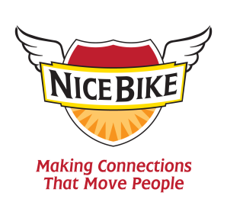

Keynote Introduction for Mark Scharenbroich (pronounced Sharon-brock)

Strong connections are vital in our lives, yet in today’s “virtual world” it is often difficult to make meaningful connections. When team members are truly connected – retention improves, sales increase, customer loyalty soars and our business grows.

Today, you will be hearing messages that are designed to fuel our passion to both connect and serve others.

Keynote speaker, Mark Sharon-brock wrote an award-winning book on connecting, entitled: Nice Bike – Making Meaningful Connections on the Road of Life.

Mark has spent his career working in both education and business discovering how some of the best organizations and industry leaders build a culture that encourages personal and professional growth.

Mark is a native of Minnesota, is an Emmy award-winner, Hall of Fame speaker and award winning filmmaker. He is a Scorpio, enjoys longs walks on the beach, bacon and beekeeping.

Please welcome, Mark Sharon-brock.

