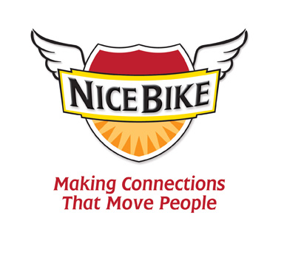
(Word Count: 220)

“Nice Bike – Making Meaningful Connections.”

Mix thousands and thousands of black leather, bandana wearing, tattoo bearing Harley-Davidson riders with a 100th Anniversary and one beige rental car and the end result will be the perfect metaphor for connecting with others: “Nice Bike.”

Join Emmy award-winning speaker, Mark Scharenbroich as he takes you for a fun ride on how to be effective at making meaningful connections in both your professional and personal life. His Nice Bike principle is supported by three strong actions: Acknowledging, honoring and connecting.

Mark tells engaging stories focused on the relationship side of creating results, connecting administrator to faculty, team member to team member, teacher to student and student to student. Schools with a strong culture of connections drive improvements in academic performance.

Mark has spent his career speaking in more than 3500 schools throughout North America. Along the way, he has discovered the keys that transform good schools into schools of excellence.

Part motivational speaker, part thought-provoker and pure comedic entertainer – Mark Scharenbroich will inspire, teach and engage you with Nice Bike.

Credentials: Award Winning Author, Emmy Award® winner for an ABC TV special, National Speakers Association Hall of Fame Inductee, Golden Apple and Silver Screen Film award for his movie, The Greatest Days of Your Life…(so far), International film festival award winner.
www.NiceBike.com

