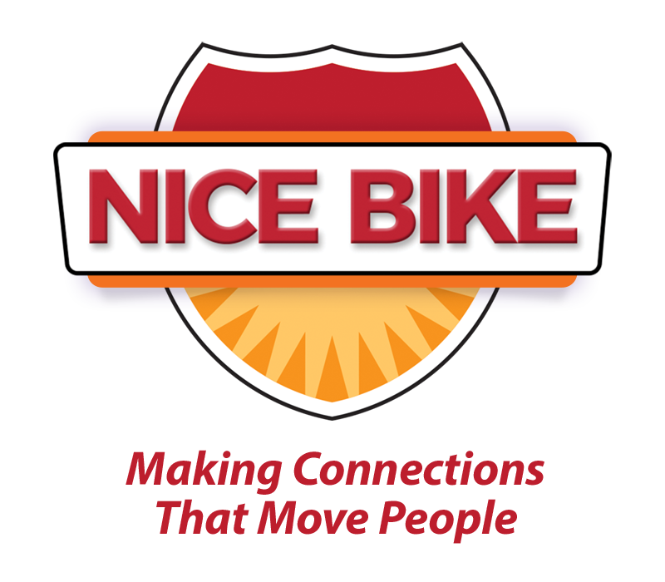
Introduction for Mark Scharenbroich
(Last name is pronounced “Sharon-brock”)

In a world where we are constantly interacting and communicating through screens, face to face interactions are more important than ever.

Human connection is the heartbeat of the business world. Meaningful connections motivate, build trust and inspire change.

In a business culture where team members feel connected and valued, retention improves, sales increase, customer loyalty soars and our business grows. Today, you will be hearing messages that are designed to fuel our passion to both connect and serve others.

Keynote speaker, Mark Sharon-brock has spent his career working in both education and business discovering how some of the best organizations and industry leaders build a culture that encourages personal and professional growth.

Mark is the author of an award-winning book on human connection, entitled: “Nice Bike – Making Meaningful Connections on the Road of Life.”

Mark is a native of Minnesota, is an Emmy award-winner, Hall of Fame
speaker and for the past two years, cited as one of the top 30 motivational speakers by Global Gurus.

He is a Scorpio, enjoys long walks on the beach and apple smoked bacon.

Please welcome Mark Sharon-brock.

