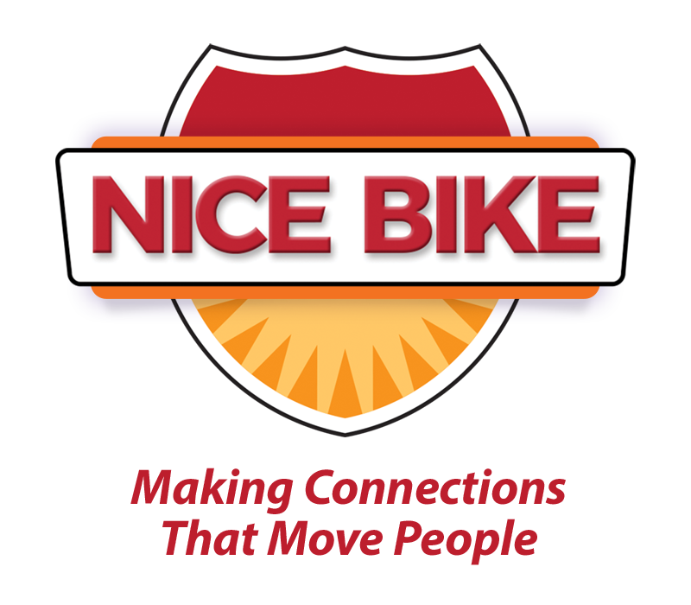
(Word Count: 173)

“Nice Bike – Making Meaningful Connections.”

In a world where real connections are often lost in the noise, Mark Scharenbroich delivers a message that resonates long after the applause fades. Through perfectly timed humor, powerful storytelling, and undeniable wisdom, Mark brings to life the Nice Bike metaphor—an unforgettable lesson in acknowledging, honoring, and connecting with others in meaningful ways.
Whether leading a team, serving customers, or strengthening relationships, true success starts with human connection. Mark masterfully shows audiences how to create a culture where people feel valued, engaged, and inspired to perform at their highest level.
His dynamic keynote isn’t just another speech—it’s an experience. One filled with laugh-out-loud moments, eye-opening insights, and real-world strategies you can immediately apply to fuel teamwork, boost morale, and drive results.
As an Emmy Award-winning speaker, National Speaker’s Association Hall of Fame inductee, and award-winning author of Nice Bike — Making Meaningful Connections on the Road of Life, Mark has spent his career uncovering what makes top organizations and leaders thrive.

www.NiceBike.com
Linkedin: https://www.linkedin.com/in/mark-scharenbroich-nice-bike

